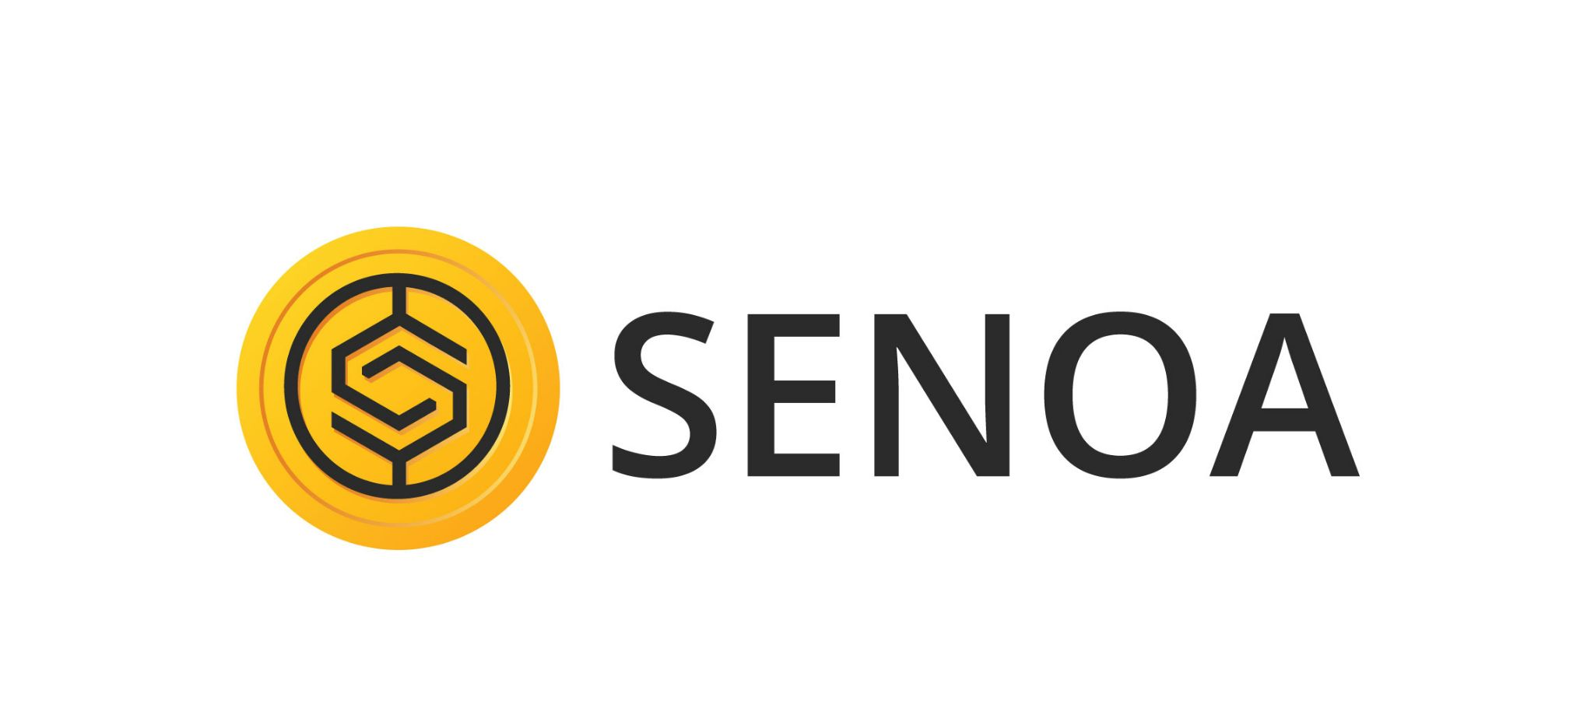

[Community driven Liquidity & Collateralization Ecosystem ]

Senoa Network   
Litepaper v0.3  
June, 2021

**Executive Summary** **3**

**Introduction** **4**

**The Problem** **5**

**Questions we must answer:** **5**

**The Solution** **6**

**Senoa Community** **6**

**Ecosystem Overview** **7**

**Oracles** **9**

**Platform Services** **9**

**Lending & Borrowing** **10**

**Dasset Administration** **10**

**What is a Dasset Administrator?** **10**

**Managed Liquidity Pool (LP)** **10**

**Governance** **10**

**Senoa Protocol** **11**

**Transaction Fee** **11**

Token Distribution 11

**Staking** **12**

**How do liquidations work?** **12**

**proof of reserve** **13**

**Roadmap** **13**

**Contingency Planning & Risk Mitigation** **13**

**Closing Remarks** **13**

**Legal Disclaimer** **14**

## Executive Summary

Centralized Finance has become a trending term in recent years, due to the influx of successful blockchain based Decentralized Finance(DeFi) platforms. Since before the inception of Ethereum, negative connotations have been cast over the alternative finance space. Mostly impart due to the monopolized institutions that implement barriers to innovate the industry.

Looking at the progression of the cryptocurrency landscape till date, a commercially viable ecosystem has materialized. Yet still, truly diverse community governed financial instruments are deeply coveted. DeFi services disrupt the traditional finance control over specific processes. These are Innovations that enable fair inclusion for providers of liquidity, economic incentives, collaborative governance, and rapid settlement with self executing smart contracts. As an increasingly evolving area in the blockchain ecosystem, DeFi examples have persisted for many years. Although, this recent crypto revolution has stimulated curiosity from enterprises, corporate treasuries, investment funds, and governments.

DeFi does raise additional risks that are not a burden in traditional finance, pertaining to sensitive consumer protection, uninsured funds, governance bureaucracy, economical and technology implementation risks. While some questions persist about the extent of decentralization that are maintained in certain protocols.

Innovations in DeFi are synchronizing services with off-chain systems, as sources of truth. With a governance model interconnecting these streams of data to self executing contracts governed by the proposed frameworks supported by the community.

This paper synthesizes an overview of the core components in the *Senoa Network.* That leverages a deflationary token ecosystem, with a governance framework that enables stateful regulation for its community holders.

## Introduction

Senoa Network introduces a collateralization framework for frictionless borrowing and lending for DeFi and traditional investors that are looking to diversify their portfolio. Senoa Community is purposely built to have a socially influenced economic incentives model that aligns with the governance of asset opportunities that are shared to community holders that stake their Senoa in approved asset bundles called Dynamic Assets(D’assets). Which are digital representations of ownership pertaining to the asset stored in the form of an NFT.

Senoa provides anyone the ability to define and launch an on-chain D’asset bundle representing liquid collateral in order to acquire support from the DeFi pools. Senoa streamlines a framework for DeFi liquidity access, and ability for any business to collateralize their assets. An opportunity for investors is a balanced offering of real life hard asset and crypto markets connected to form attractive growth yet stable and more reliable returns. Through SNOW static reflection, investors can produce additional yield just by participating in the ecosystem.

Senoa is built on the Binance Smart Chain, although a full migration to a Senoa Chain with managed infrastructure is planned. This will allow validators, evaluations, risk mitigation and contingency planning for any kind of assets to be performed autonomously and seamlessly. This enables fully liquid markets to develop around these assets.   
  
Senoa integrates digital and physical hard assets into DeFi, which avails lower capitalization cost, while managing a consistent rate of return for the DeFi community. To have a balance with traditional and DeFi products, a hybrid approach is taken. In order to provide equal opportunity and awareness to Senoa token holders, a social landscape is provided to interact with the D’asset’s under management. Along with the ability to engage with real estate assets in a dynamic environment where the data is updated in near real time.

## The Problem

Rugpulls

* Poor governance mechanisms
* Oracle price issues
* Liquidity risks
* Stable coin depegging risk(baskets
* Equal opportunity investing

## Questions we must answer:

Why Senoa? - Senoa project is the first publicly reported asset backed deflationary token. Senoa intends on maintaining full transparency, project accountability and procurement of digital and real world assets that serves as a base for our coin. Quarterly reporting will outline operational performance, digital and real world asset performance and forward looking statements. Senoa project was created with the holders in mind

What is DEFI? - Decentralized Finance and Central Decentralized Finance are a new financial system using smart contracts over blockchain. The problem solved with the DeFi product is to provide features equivalent to, and innovating, those provided from typical financing services, without dependence on any mediating 3rd party or broker.

* No trusted intermediaries required
* Uses building blocks like smart contracts
* Opposite of crypto-currency central exchanges

Why DEFI? - Decentralized finance provides an opportunity to eliminate centralized banking systems, using smart contracts over blockchain.

* No need for merchant processing integration and limitations
* Significantly less fees
* Ability to quickly create and deploy own digital asset

We are exploring 4 opportunities with Defi:

• Defi Token over BSC (Binance Smart Chain)

• Utility Development

• Digital & Hard Assets

• Exchange

Senoa Utility Development

The key to success of any coin is the ability to create utility/use cases that acts as a means of exchange. Utility cases drive buying power for our coin, which mitigates bearish/sell offs that will occur daily. This means Senoa will actively research, invest, develop and deploy opportunities that will consistently add/drive buying power, thus, reducing significant selloffs while slowly increasing the value of the coin.

SenoaDex - Exchange

Our exchange will allow potential holders to seamlessly acquire their favourite BSC and ETH coins, while eliminating the hassles typically found when acquiring coins.

## 

## The Solution

## Senoa Community

## Platform Services

The Management Team maintains the Senoa Community interface and social experience. Allowing each of the functions of the platform to create utility.   
  
Those abilities include:

|  |  |  |
| --- | --- | --- |
| Platform module | Functions | Participants |
| Social feed | * View friends * Followers/following metrics * Tags and recommendations * Verified traders/Administrators * Latest marketplace offerings | * Senoa Token holders * Dasset Administrators * Borrowers |
| Profile | * Profile restricted to private until achieving verification levels. * Share ideas, trades, transactions(P&L), comments, and collaborate on D’asset bundles. * Image/Video sharing | * Senoa Token Holders * Dasset Administrators * Borrowers |
| D’assets marketplace | * Filtering * Following * Staking * Redemption | * Senoa Token Holders * Dasset Administrators |
| Lending & Borrowing | * Apply to issue Dassets * Dasset builder * analytics * Asset holdings | * Senoa Token Holders * Dasset Administrators |

## Ecosystem Overview

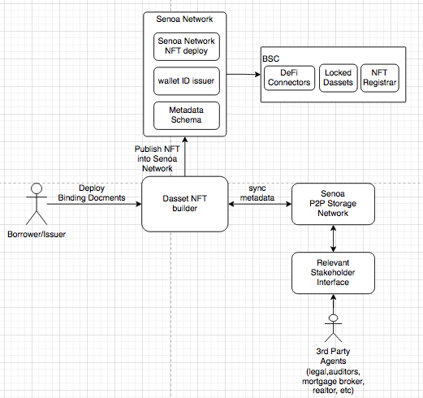

The diagram above defines the flow to create a dynamic, secure and viable network of single or multi-asset NFT’s with market-specific regulated policies, that are validated through a governance process that empowers token holders with the control to determine the path forward.

The primary objective of the Senoa Community is to propose, validate, and approve, short to mid term lending opportunities via fully collateralized assets represented in the form Non-Fungible Tokens(NFT). Each NFT is designed utilizing BEP721 - deployed on the Binance Smart Chain(BSC). From a user perspective, buying and selling Senoa offerings using BSC is more affordable. Ethereum is currently not in consideration due to the high fee’s of transactions that make trading our NFTs too expensive for the flexibility expectations of the Senoa collectors.

Based on the provided digital(collection of cryptocurrency tokens,nfts,etc) or physical asset collateral(promissory notes for mortgages, invoices, real estate) which represent the ownership and transferability of the assets or it’s equity value, issuers can deploy a Senoa Dasset(NFT).

The Dasset is now coupled with documents stored in the ipfs entity. Which has its own lifecycle, that will be transferred into the time locked collateral interface, in order to initiate the capitalization process.

The Senoa protocol functions in several use cases, all of which require a framework for prevention of derived risk. If relevant to the asset devaluation that has any association with the lender or borrower, ultimately affecting the community as a whole. Thus, privacy is a predominant construct of the Senoa ecosystem. Senoa’s Dassets(NFT) are in the simplest form, a combination of the assets provided document hash signatures, with traceable metadata for attributing private information on the decentralized ledger.

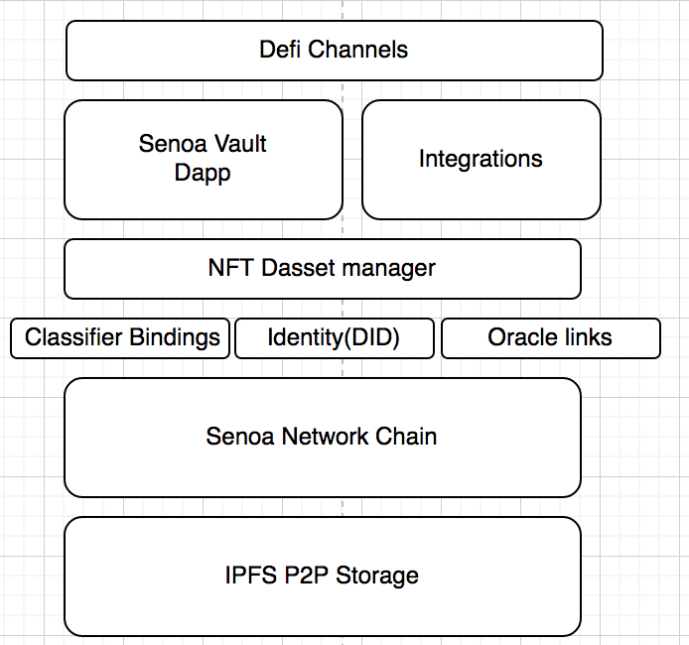

Senoa’s asset issuance process follows an intentionally lean standardized framework for deploying an NFT that can be minted with the Dasset Issuance Interface; in order to avoid leaking of data, the framework is limited to set parameters to define its lifecycle with a set of key mandatory parameters, for example:

* The ability to verify the owner has a specified wallet or designation on the physical document and is permitted to issue the NFT (e.g., only the asset issuer can create the NFT for a document).
* Each entity participating in the duration of the loan must have signed the document state (e.g., buyer & supplier).

The Dasset’s metadata defines a path back to the public ledger contracts and to the private document on the p2p network storage endpoint. The immutable and versioned ledger data identifies the unique documents and permits Senoa holders of that specific Dasset to parse the status, modifications, and ability to exchange their collection within the network. If the holder of the NFT requires to exit their position before the end of the term, an eligible buyer in the community can acquire the position, allowing the seller to liquidate their position for an unfavourable fee along with an early settlement penalty from the community.

## Oracles

Defining an open market model enables a full suite of secondary attributes to assess a Dasset’s appreciation. Pluggable oracle data leveraging Chainlink incentivizes the community to apply more pressure for transparency that enables metrics to help address the price discovery issue of NFT’s. By leveraging multiple sources for estimations of residential and commercial real estate values from multiple sources providing an index of averaged Automated Valuation Model (AVM).

This comes with a burden on network load, community oversight, streamlining integration of data sources, and the additional overhead to borrowers. Although, a borrower will try their best to achieve the most beneficial terms. If not, the risk profile is increased and appropriate disclosures predefined by the community will be presented to the lender.

## Lending & Borrowing

## Dasset Administration

### What is a Dasset Administrator?

Dasset administrators manage the risks and administrative overhead for borrowers looking to access financing through the Liquidity Pools. Senoa provides a decentralized asset management infrastructure empowering Administrators to make decisions on whether to provide funding to the Senoa Dasset issuers, increasing their potential Assets Under Management(AUM) while yielding performance reward fees also governed by risk-averse rating criteria. The more risk added to a portfolio, the less performance reward will be yielded, discouraging the Administrator from approving certain offerings.

## Managed Liquidity Pool (LP)

Each Liquidity Pool is managed by the relevant Asset Administrator. They are responsible for the entire lifecycle of the asset. Negotiating terms of the loan with the borrowers, executing due diligence checklists, preparation of wallet ID, coordinates the legal agreement between the collateral entity and Senoa, uploads of binding documents, issuance of NFT, and liquidating collateral in the event of a default. Administrator's review a Borrower's reputation, expertise, and performance to evaluate terms of the loan. Once the Borrower and Administrator agree to the interest and collateral ratio, Administrators sign the transaction signaling their approval to fund the loan of the proposal request.  
  
How to become a asset Administrator

* Membership node, validator
* Staking node requirement

## Governance

As the Senoa protocol moves towards full decentralization, SNOW holders will gain more responsibility over the governance. SNOW holders may submit a vote on any proposed modifications to the protocol, including the structured data parameters associated with the issuance of any Dasset, any manual burning of SNOW Tokens, and other network level updates. SNOW holders are able to delegate their voting rights.

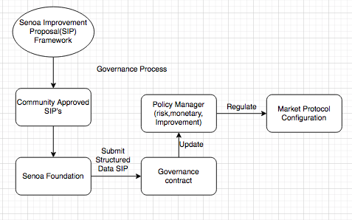

## Senoa Protocol

### Transaction Fee

Senoa leverages deflationary functions in all transfers of SNOW via Reflection/redistribution, acquiring LP, and a burn per trade. Each transaction is taxed a total fee of 10%, which is divided four ways:

* 2.5% fee redistributed to all existing token holders.
* 2.25% transaction fee of the tokens are split 50/50 value between SNOW/BUSD to automatically capitalize the liquidity pool on PancakeSwap.
* 1.25% management fee
* 4% to securitized assets

### 

### 

### 

### Token Distribution

Senoa leverages the deflationary strategy functions in the transfer of Senoa via Reflection, LP acquisition, and a burn per trade. Each transaction is taxed a total fee of 10%, which is divided four ways:

* 2.5% fee redistributed to all existing holders
* 2.25% fee of the Senoa tokens are allocated to pair automatically with the BUSD and added as a liquidity pair on PancakeSwap.
* 1.25% management fee
* 4% to securitized assets

## Staking

Senoa token holders are eligible to view, follow, and copy the strategies of other token holders, D’asset Administrators, or create their own bundles. The D’assets promoted are community vetted and approved to publish and receive capital. Staking in these

## How do liquidations work?

If a borrower is to miss their repayment, a grace period is predefined to make the payment before their collateral begins the liquidation process, which is executed by the Administrator assigned to that Dasset. This process triggers the contingency plan that is predefined in the structured schema of the *Locked Dassets* contract which executes repayment to the Liquidity Pools that funded the loan.

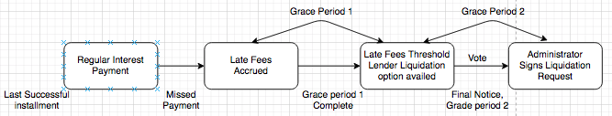

In the event of a collateral shortfall post liquidation, the total sum along with the penalty fees can be claimed from the Staking Pool on PancakeSwap, these contain SNOW and BUSD deposited by Senoa Token Holders. Staked tokens will be redeemed for stablecoin and distributed to the Liquidity Pool.

All Borrowers of physical asset collateral requiring legal entity representation must enter a Master Loan Agreement during onboarding which allows Senoa management team to follow liquidation procedures of the legal governing body.

## proof of reserve

Senoa Management team maintains a monthly summary and quarterly detailed report on operations and financial standings of all assets under management. These materials are audited and parsed into the NFT metadata that adds to the schema of attributes defined in an assets lifecycle.

## Roadmap

The Senoa Management Team must deliver the roadmap below effectively. They also act as the platform guardian performing all physical execution on behalf of the proposals defined, enabling transparent orchestration for it’s token holders.  
 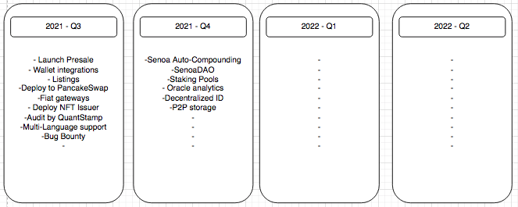

## Contingency Planning & Risk Mitigation

Initially Senoa will employ a 130% collateralization policy until the Senoa Management team and community go through the improvement proposal process. Senoa will maintain a balanced portfolio with a minimum amount of stable coin hedge at all times.

## Closing Remarks

The Senoa protocol is defining a bridge to pair real world assets with a digital twin representation on a decentrally governed ledger. One of the few hard-asset-backed ecosystems to support global aggregation of liquid collateral in the form of an NFT. Where you can hold your assets wherever you go, freely track and trade in the Senoa community, your first addressable piece of reality in the digital world.

## 

## 

## 

## 

## 

## 

## 

## 

## Legal Disclaimer

The information provided in this Whitepaper and on the SENOA website does not constitute financial advice, trading advice, investment advice, legal advice, or any sort of advice whatsoever, and you should not treat any of the Whitepaper or website's content as such. The SENOA team does take every precaution to secure its token and protect investors and applies the same standards to vetting other projects that utilize the Services and Products of the applications. SENOA does not endorse or recommend that any cryptocurrency be bought, sold, or held by you or any persons. Always do your own research and conduct your own due diligence to determine a project's success prospects.By purchasing SNOW, you agree that you are not purchasing a security or investment. You also agree to hold the team harmless and not liable for any losses or taxes you may incur. You also agree that the team is presenting the token "as is'' and is not legally required to provide any support or services. You should have no expectation in any form, including guarantees of safety, price, functionality, or future feasibility of the SNOW token or any tokens launched through the SENOA platform or listed on the SENOA exchange from SENOA and/or its team.Always make sure that you comply with your local laws and regulations before you make any purchase.